ASP.NET Core 8.0 Web API
Aim:
To demonstrate Action Return Types, the use of the FromBody attribute, and implement a Custom Authorization Filter in an ASP.NET Core Web API.
Objectives:
- Demonstrate the use of ActionResult<T> in Web API.
- Demonstrate the use of the [FromBody] attribute.
- Create model classes with nested objects.
- Implement a Custom Authorization Filter.
- Verify API responses using Swagger.
Tools Used:
- Visual Studio 2026
- ASP.NET Core Web API (.NET 10)
- C#
- Swagger UI
Procedure:

Step 1: Create Model Classes
Created the following model classes inside the Models folder:
- Employee
- Department
- Skill
The Employee model contains properties such as Id, Name, Salary, Permanent, Department, Skills, and DateOfBirth.

Step 2: Create Employee Controller
Created EmployeeController with the following actions:
- GET – Returns a list of Employee objects using ActionResult<List<Employee>>.
- POST – Accepts an Employee object using the [FromBody] attribute and returns the received object.

Step 3: Execute GET Method
- Executed the GET /api/Employee endpoint using Swagger.
- Verified that the API returned the employee list successfully with 200 OK status.

Step 4: Execute POST Method
- Executed the POST /api/Employee endpoint.
- Passed an Employee object in the request body and verified that the same object was returned with 200 OK status.

Step 5: Create Custom Authorization Filter
- Created a Filters folder and added CustomAuthFilter.cs.
- Implemented IAuthorizationFilter to check for the Authorization header.
- If the header is missing, the filter returns 401 Unauthorized.

Step 6: Apply Authorization Filter
- Applied the [CustomAuthFilter] attribute to the EmployeeController.
- Executed the GET method again without an Authorization header.
- Verified that the API returned 401 Unauthorized.
Figure1: Visual Studio showing the EmployeeWebAPI project structure.
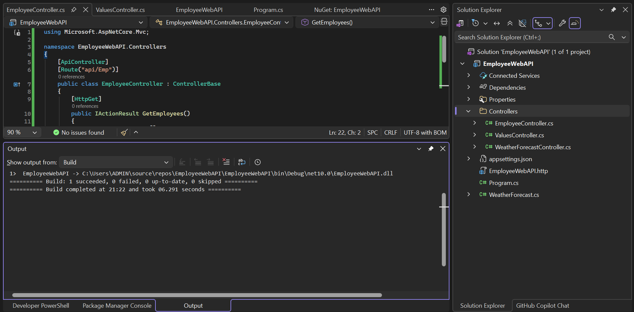

Figure2: Swagger Home Page displaying Employee and Values API endpoints.
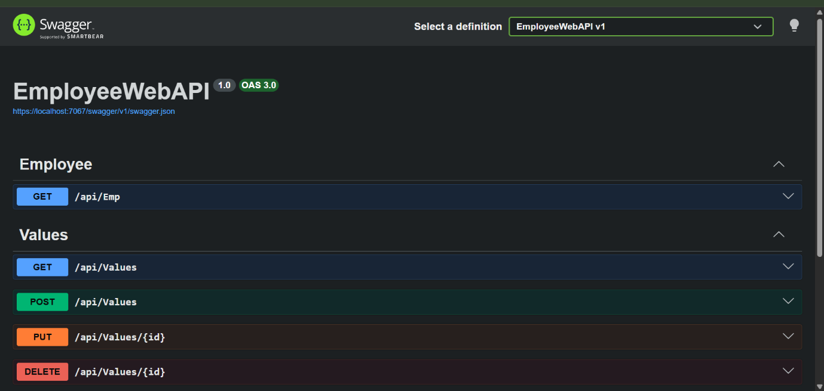

Figure3: Employee model showing the properties of the Employee class.
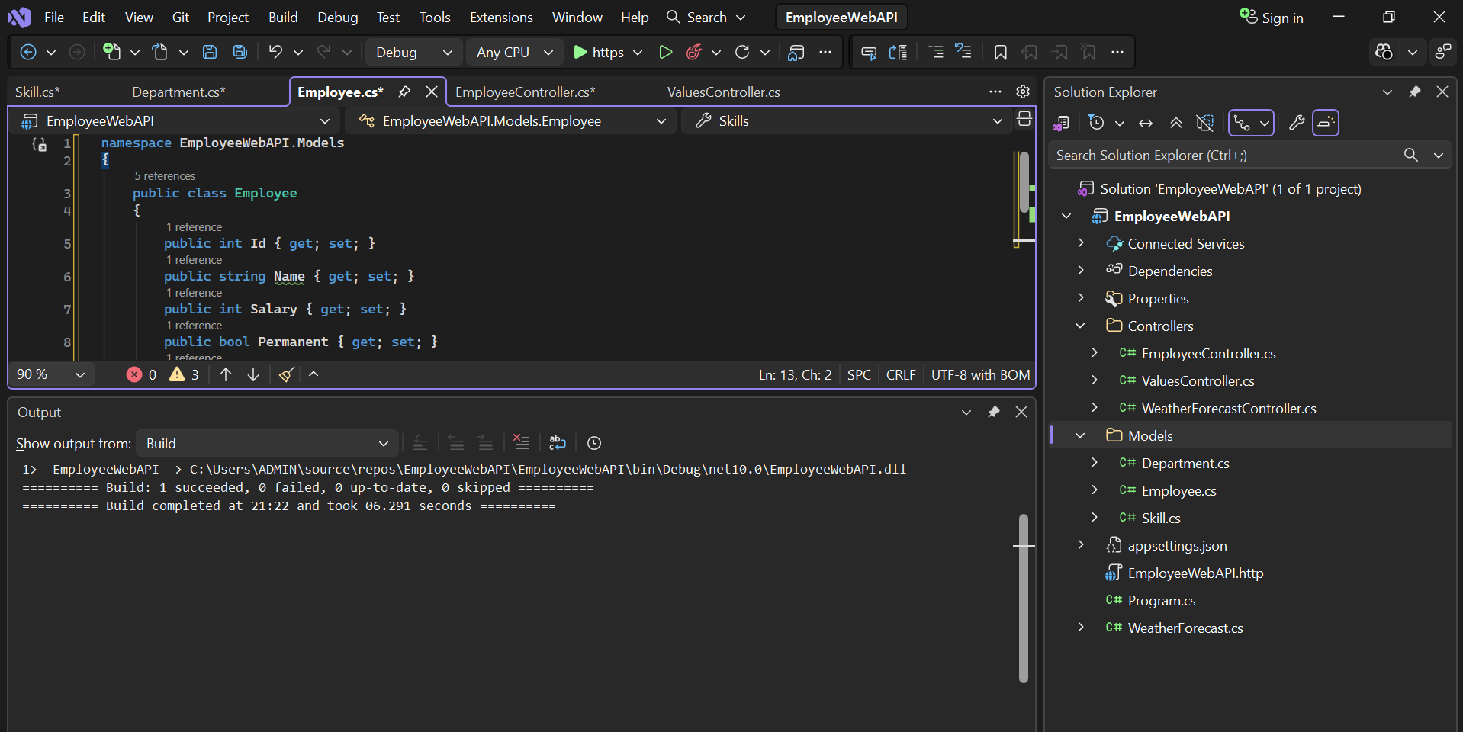

Figure4: Swagger GET /api/Employee response.
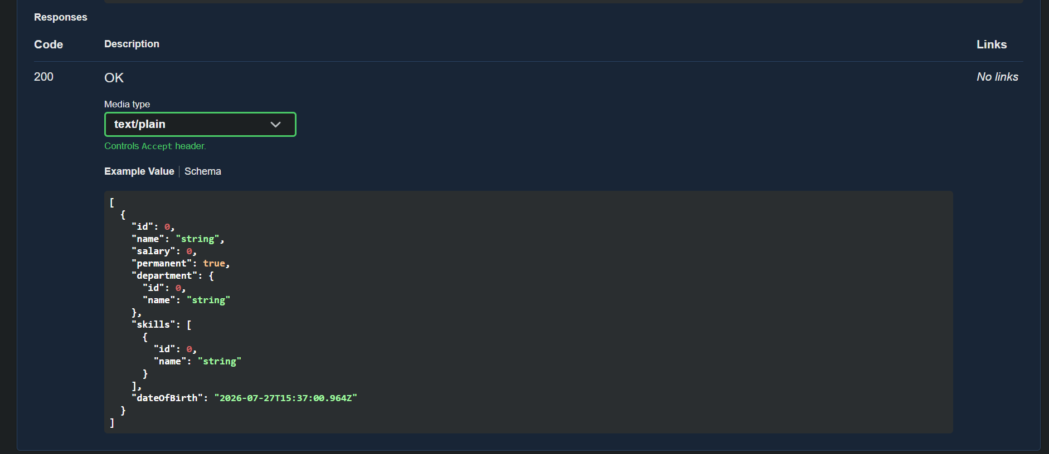

Figure5: Swagger POST /api/Employee response.
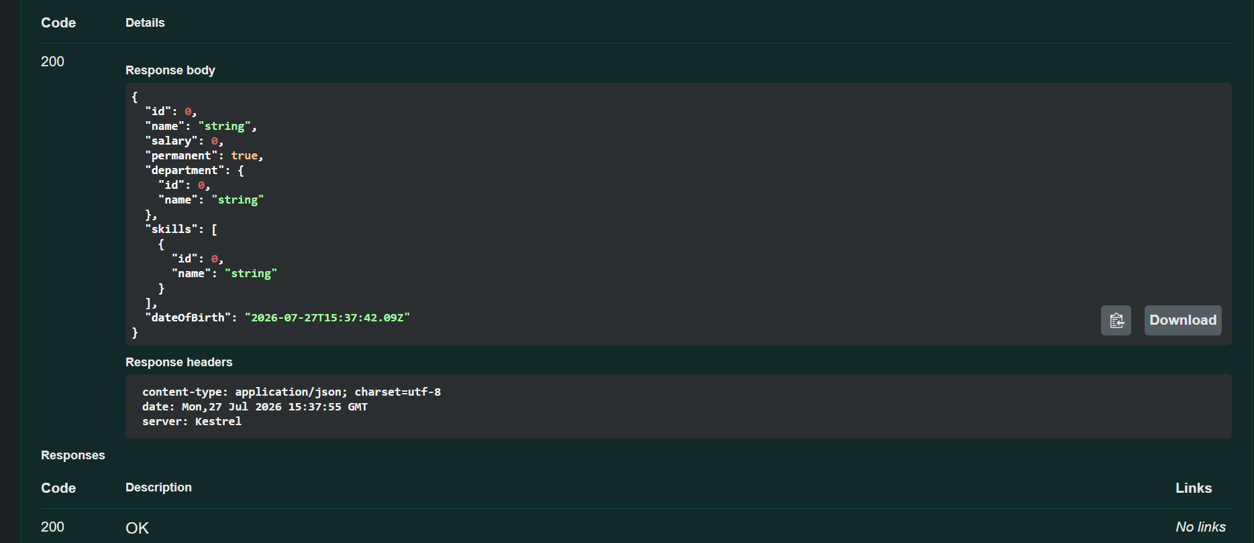

Figure6: EmployeeController showing the Custom Authorization Filter.
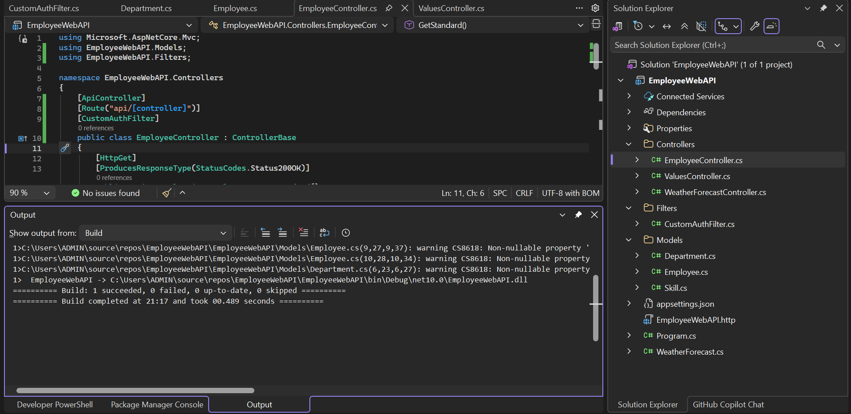

Figure7: Swagger response showing Unauthorized (401) status after applying the Custom Authorization Filter.
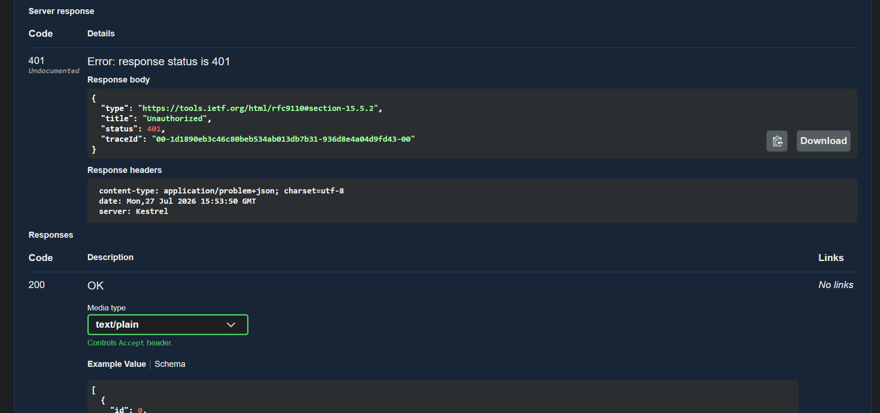
Result:
Successfully developed an ASP.NET Core Web API with an Employee model and implemented GET and POST operations. A Custom Authorization Filter was applied to the Employee controller to secure the API endpoints. The application was tested using Swagger UI, and the responses were verified successfully. Unauthorized requests returned HTTP Status Code 401, confirming that the custom authorization filter worked as expected.

